Exercise 9: MongoDB Aggregation

Step 1: Baseline Metadata Initialization
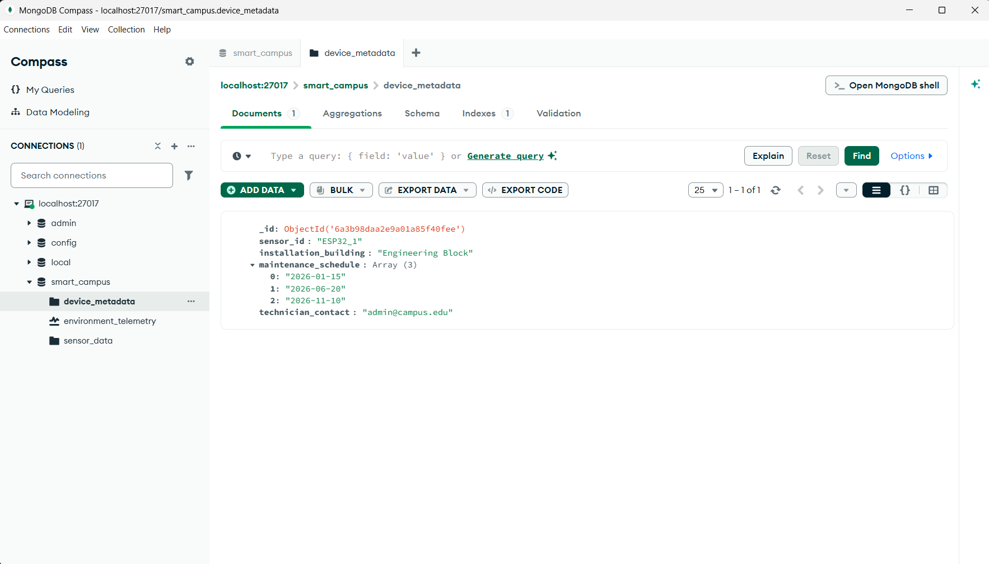

Step 2: Stage 1 Pipeline - Filtering and Shaping

-$match
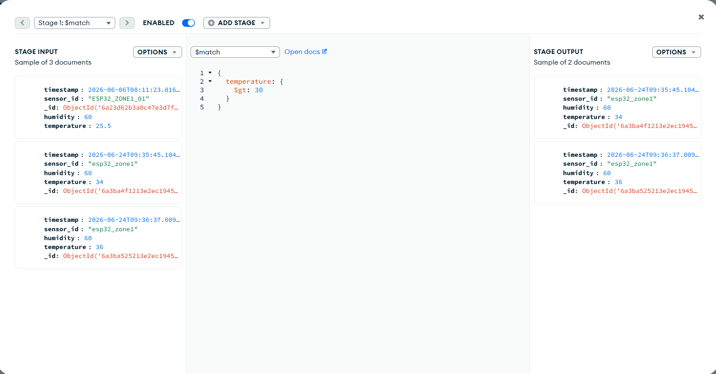
$project
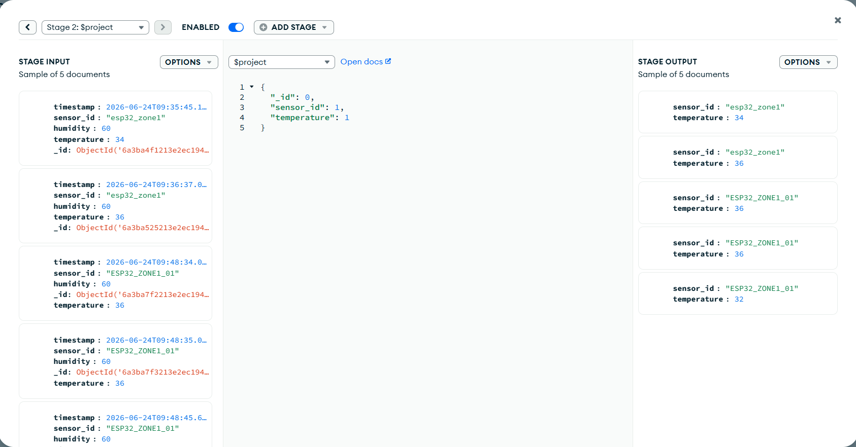

$limit
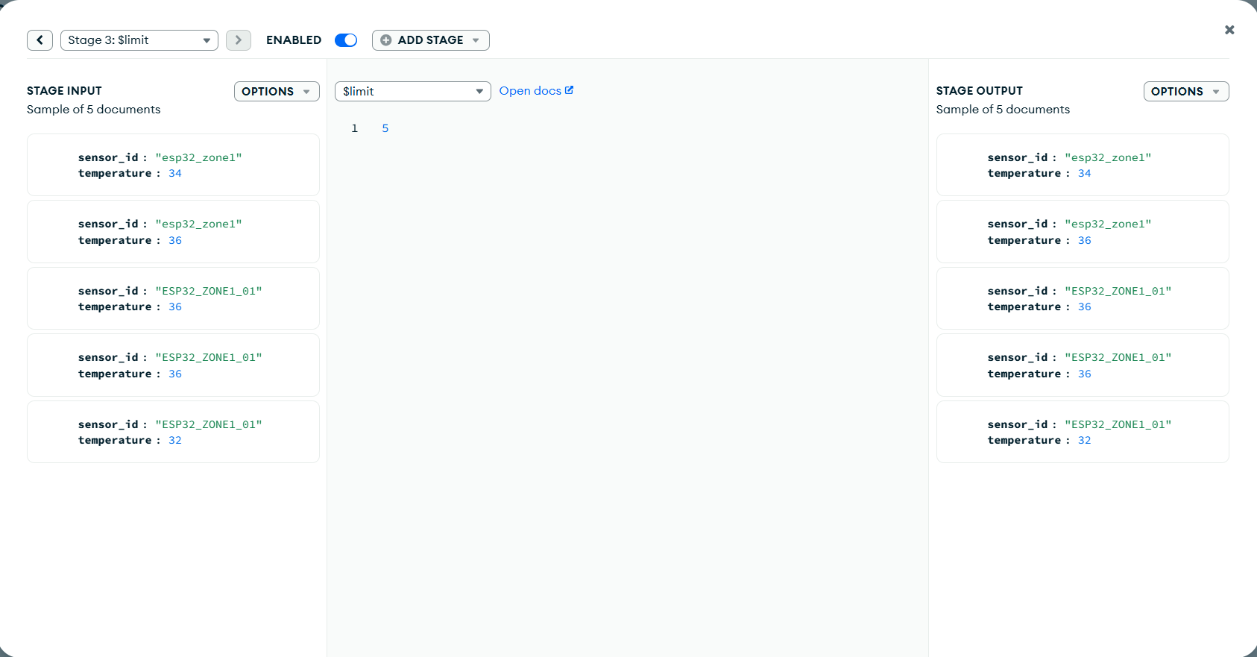

Step 3: Stage 2 Pipeline - Mathematical Reduction

$group
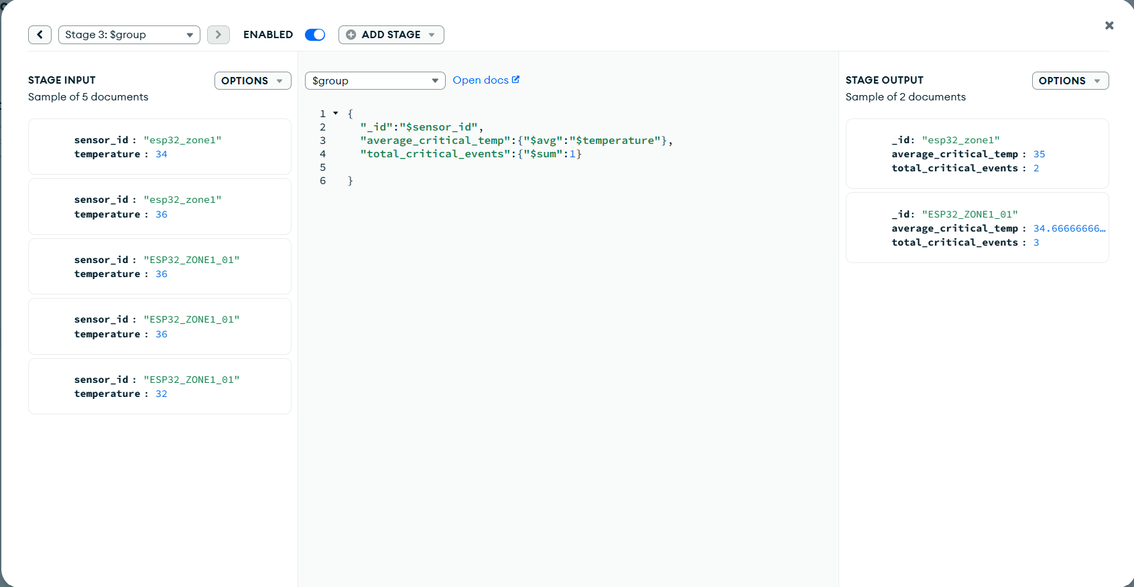

$sort
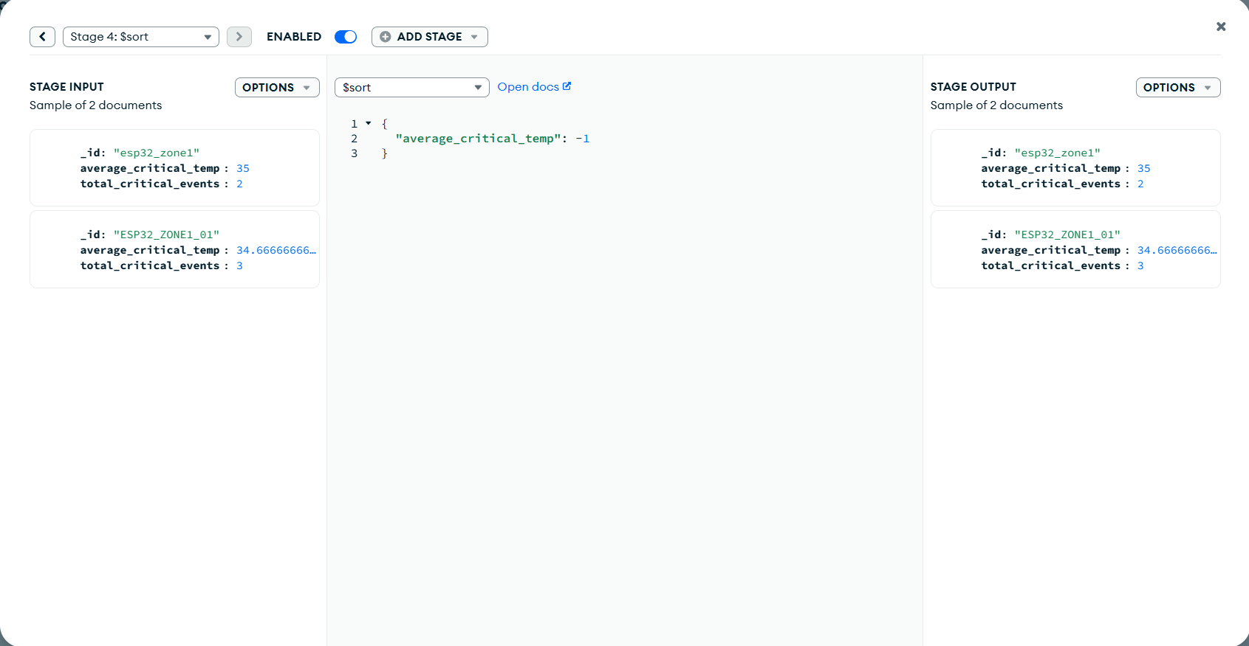
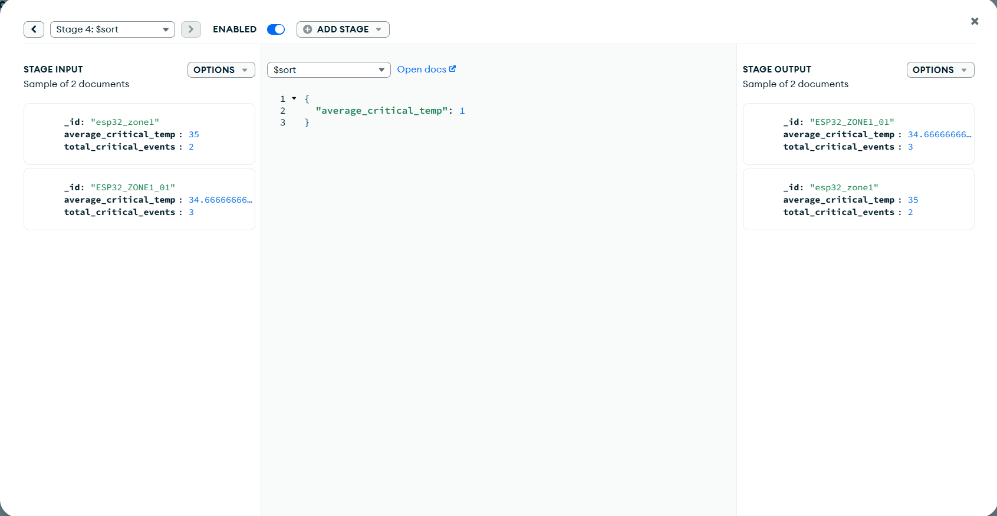
Step 4: Stage 3 Pipeline - Relational Joins & Flattening

$lookup
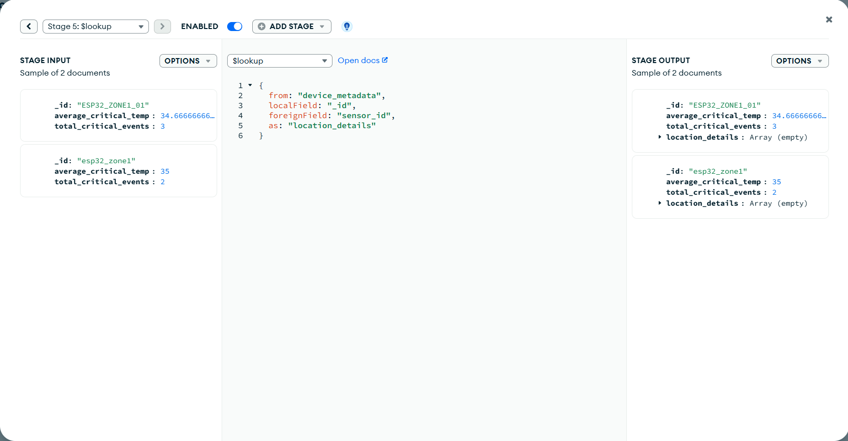

$unwind
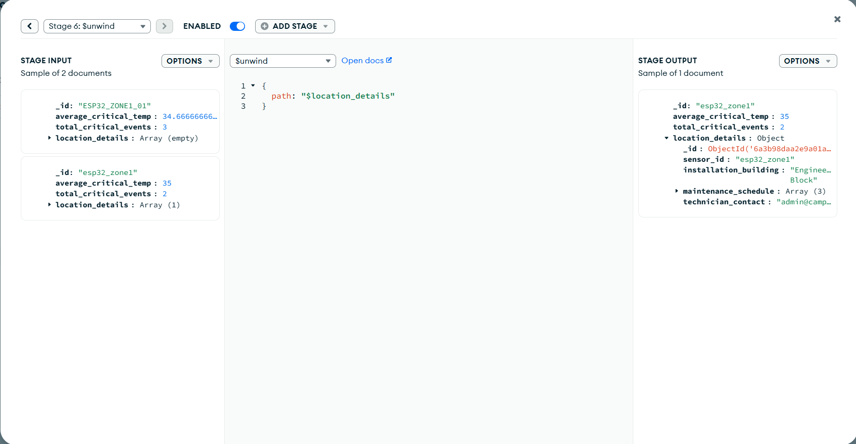

Step 5: Execution via Node-RED Middleware
